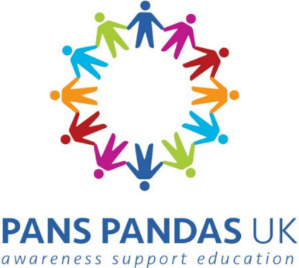

Youth Advisory Board Application

Name:

Age and date of birth:

E mail address we can contact you on:

Parent/carer’s e mail address and mobile phone number for those under 18:

Email: Mobile:

Are you
- a child or young person living with PANS or PANDAS

- a sibling or close friend/relative of a child or young person living

with PANS or PANDAS

Please tell us a little about why you would like to join the PANS PANDAS UK Youth Advisory Board

If you are under 18, do you have parental permission to participate? Yes / No

How would you feel most comfortable contributing to the Youth Advisory Board (please tick any that apply)

- In a virtual group meeting on camera

- In a virtual group meeting with camera off and using chat function

- In a 1-1 virtual meeting with a member of the charity staff

- Via e mail

- Through a messaging app (like WhatsApp)

Thank you for taking the time to complete this form. We will be in touch as soon as we have had time to review all applications.

Send this form to: katy.hindson@panspandasuk.org

